Experiment - 05
Building Reports and an Interactive Dashboard for Patient Appointment & Scheduling Management
SAI PRANAV B.V
241401088 CSBS
AIM
To design and build custom reports and an interactive dashboard for the Patient Appointment & Scheduling Management application using Zoho Creator Page Builder.
REPORTS CREATED
The following reports were created from the Appointment_Booking_Form to support appointment analysis and dashboard functionality.
Report | Purpose and Relevant Fields | Grouped By
Appointment_Booking_Report | Main appointment report containing the submitted appointment records. | —
Department_Wise_Appointment_Report | Analyses the number of appointments in each department. Fields: Patient Name, Email Address, Contact Number, Department, Preferred Appointment Date, Preferred Appointment Time, Appointment Status. | Department
Appointment_Date_Wise_Report | Monitors appointments according to their preferred appointment date. Fields: Patient Name, Department, Preferred Appointment Date, Preferred Appointment Time, Appointment Status, Contact Number. | Preferred Appointment Date
Appointment_Status_Report | Analyses appointments according to their current status (Pending, Confirmed, Completed, Cancelled). | Appointment Status
PROCEDURE
Step 1: Add Appointment Status
An Appointment Status dropdown field was added to the Appointment_Booking_Form with the choices Pending, Confirmed, Completed, and Cancelled. This field is used to monitor the progress of each appointment.
Step 2: Create Department-Wise Appointment Report
A report named Department_Wise_Appointment_Report was created using Appointment_Booking_Form. It was configured to display patient, contact, department, appointment date/time, and appointment status information, and the records were grouped according to Department. This report supports the department-wise appointment chart used in the dashboard.
Step 3: Create Appointment Date-Wise Report
A report named Appointment_Date_Wise_Report was created to organise appointment records according to Preferred Appointment Date. It is useful for monitoring the number of appointments scheduled on different dates.
Step 4: Create Appointment Status Report
A report named Appointment_Status_Report was created with the records grouped according to Appointment Status. This allows appointment records to be analysed based on whether they are Pending, Confirmed, Completed, or Cancelled.
Step 5: Create Appointment Dashboard
A custom page named Appointment_Dashboard was created using Zoho Creator Page Builder. The dashboard was designed specifically for appointment scheduling and front-desk monitoring, and contains KPI panels, charts, an upcoming appointment table, search functionality, and a navigation button, as laid out in Fig 1.
DASHBOARD COMPONENTS
1–5. KPI Panels
Five Panel components were created to display appointment counts on the dashboard.
Panel | Display | Criteria
Total Appointments | Count | All Records
Pending Appointments | Count | Appointment Status = Pending
Confirmed Appointments | Count | Appointment Status = Confirmed
Completed Appointments | Count | Appointment Status = Completed
Cancelled Appointments | Count | Appointment Status = Cancelled
6. Appointments by Department
A chart was added to show the number of appointments in each department, for example General Medicine, Cardiology, Dermatology, Pediatrics, and Orthopedics. It uses Appointment_Booking_Form as the data source, Department as the category, and Count of Appointments as the value.
7. Appointments by Status
A chart was added to show the distribution of appointments according to their current status (Pending, Confirmed, Completed, and Cancelled), using Appointment Status as the category and Count of Appointments as the value.
8. Appointment Date Trend
A line chart was added to display appointment volume according to the Preferred Appointment Date, with Preferred Appointment Date on the X-axis and Count of Appointments on the Y-axis.
9. Upcoming Appointments
A report was embedded as a table on the dashboard under the title Upcoming Appointments. It displays appointment records scheduled within the next 30 days, showing Patient Name, Department, Preferred Appointment Date, Preferred Appointment Time, and Appointment Status.
10. Search Appointments
A Search component was added to the dashboard so that users can quickly search appointment information by Patient Name, Department, Contact Number, or Appointment Status.
11. View All Appointments
A Button component named View All Appointments was added to the dashboard. It navigates to Appointment_Booking_Report, allowing users to move from the dashboard summary to the complete appointment records.
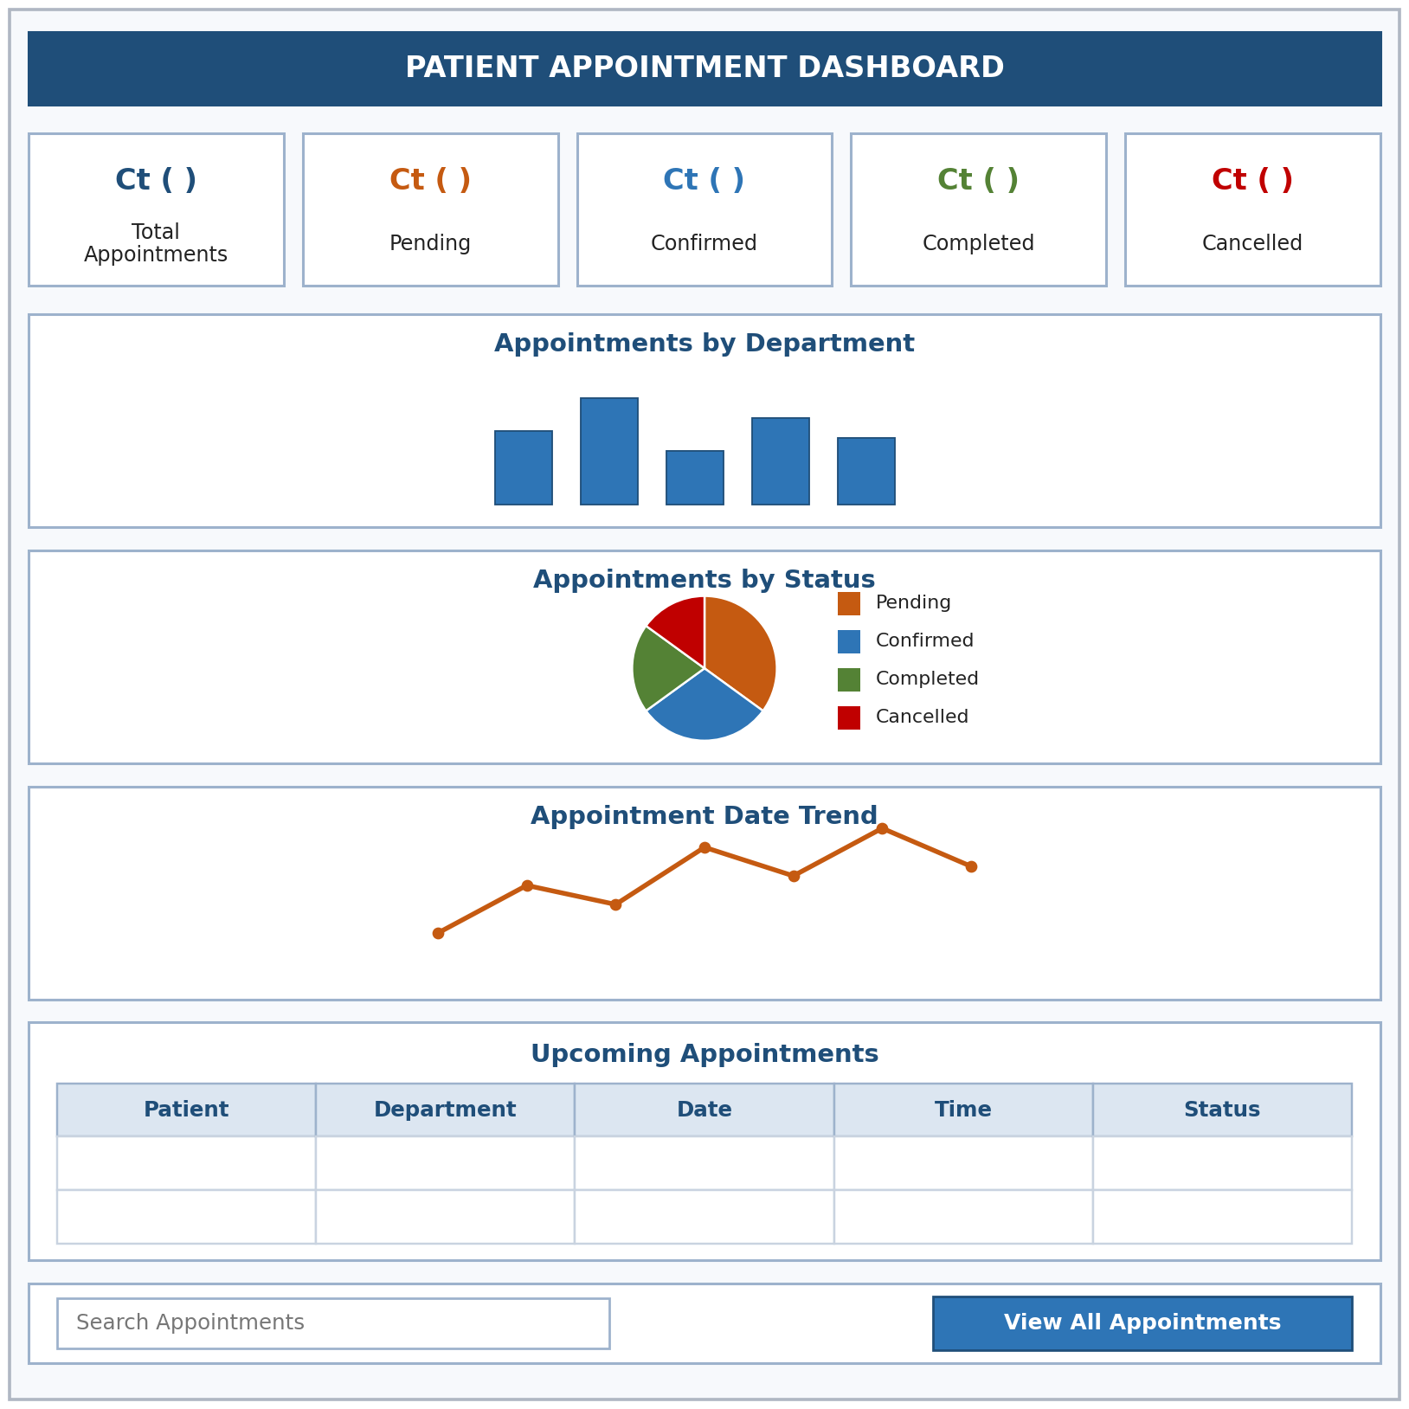
Fig 1. Layout of Appointment_Dashboard — KPI panels, charts, upcoming appointments, search, and navigation button
OUTPUT
The completed Appointment_Dashboard provides a centralised view of the appointment system. It includes the total, pending, confirmed, completed, and cancelled appointment counts, department-wise appointment analysis, appointment status analysis, the appointment date trend, upcoming appointments, appointment search, and access to all appointment records. The following screenshots capture the reports and the dashboard in Page Builder and in live mode.
1. Reports Created in Zoho Creator
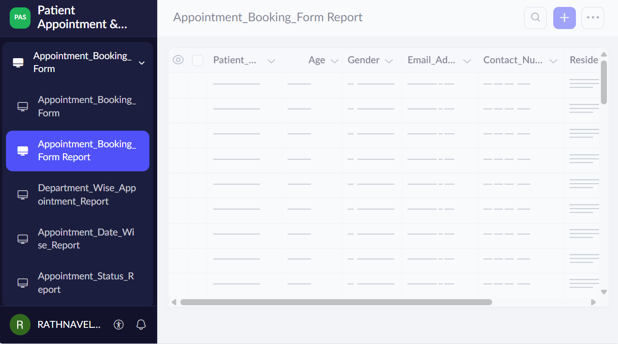
Screenshot 1 — Reports list and report configuration

2. Appointment_Dashboard in Page Builder
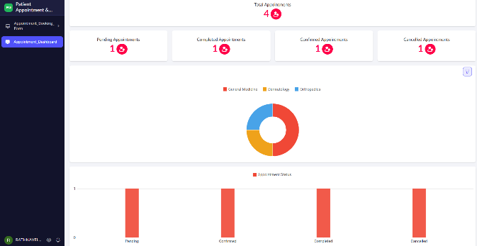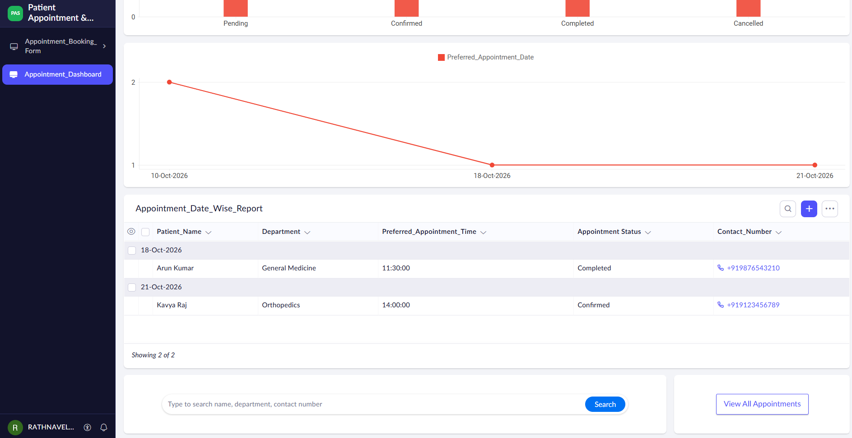
Screenshot 2 — Complete dashboard with KPI panels and charts in Page Builder

In live mode the KPI panels, department-wise chart, status chart, date trend chart, upcoming appointments table, search component, and View All Appointments button were verified, and all dashboard components were displayed successfully.
RESULT
The Patient Appointment & Scheduling Management application was successfully enhanced with custom reports and an interactive dashboard using Zoho Creator Page Builder. The dashboard provides a centralised interface for monitoring appointment volume, department-wise appointment distribution, appointment status, appointment-date trends, upcoming appointments, and appointment records. It also provides search and navigation functionality for front-desk users, making the appointment management process more efficient.

